Exploratory Data Analysis Insights

**Summary Statistics:**

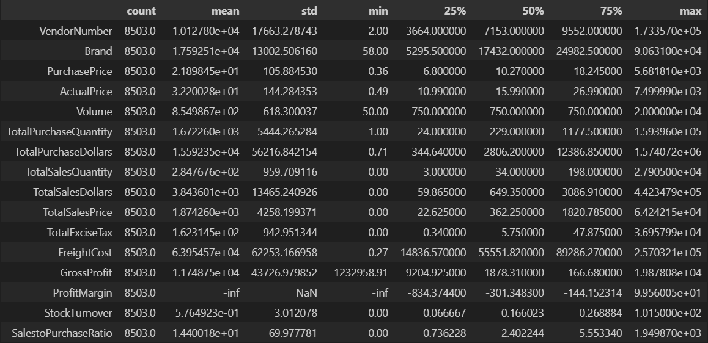

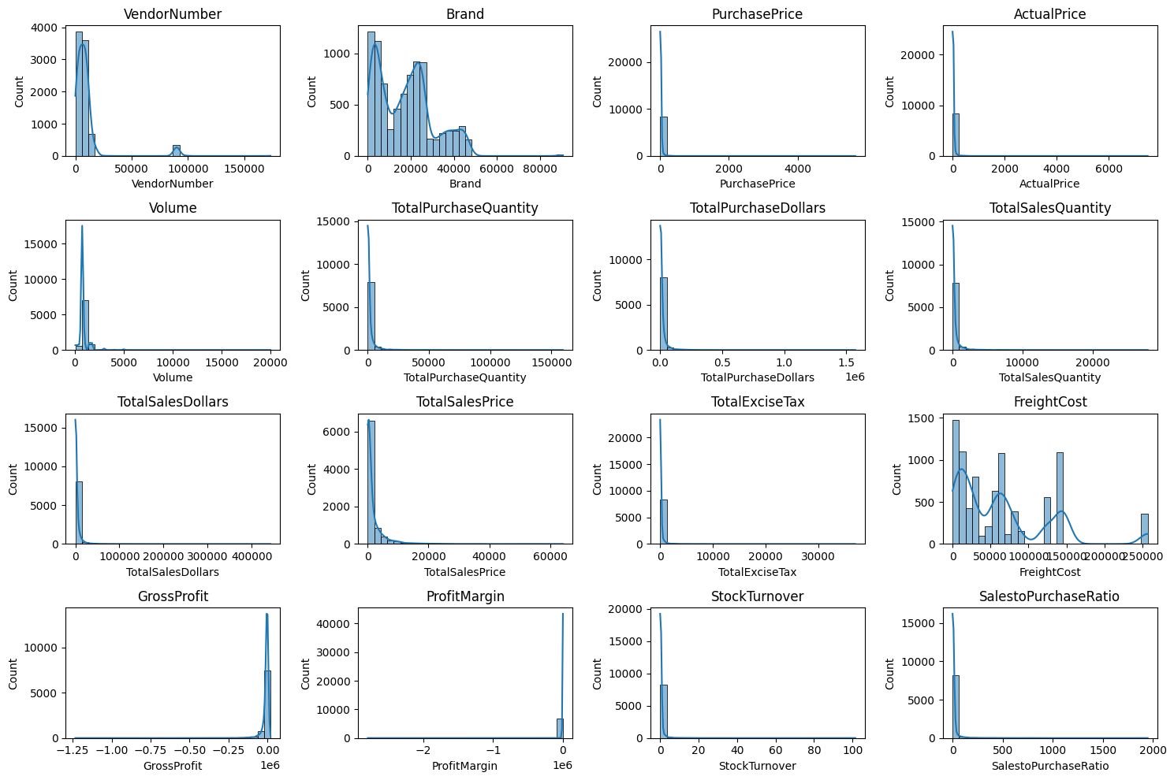

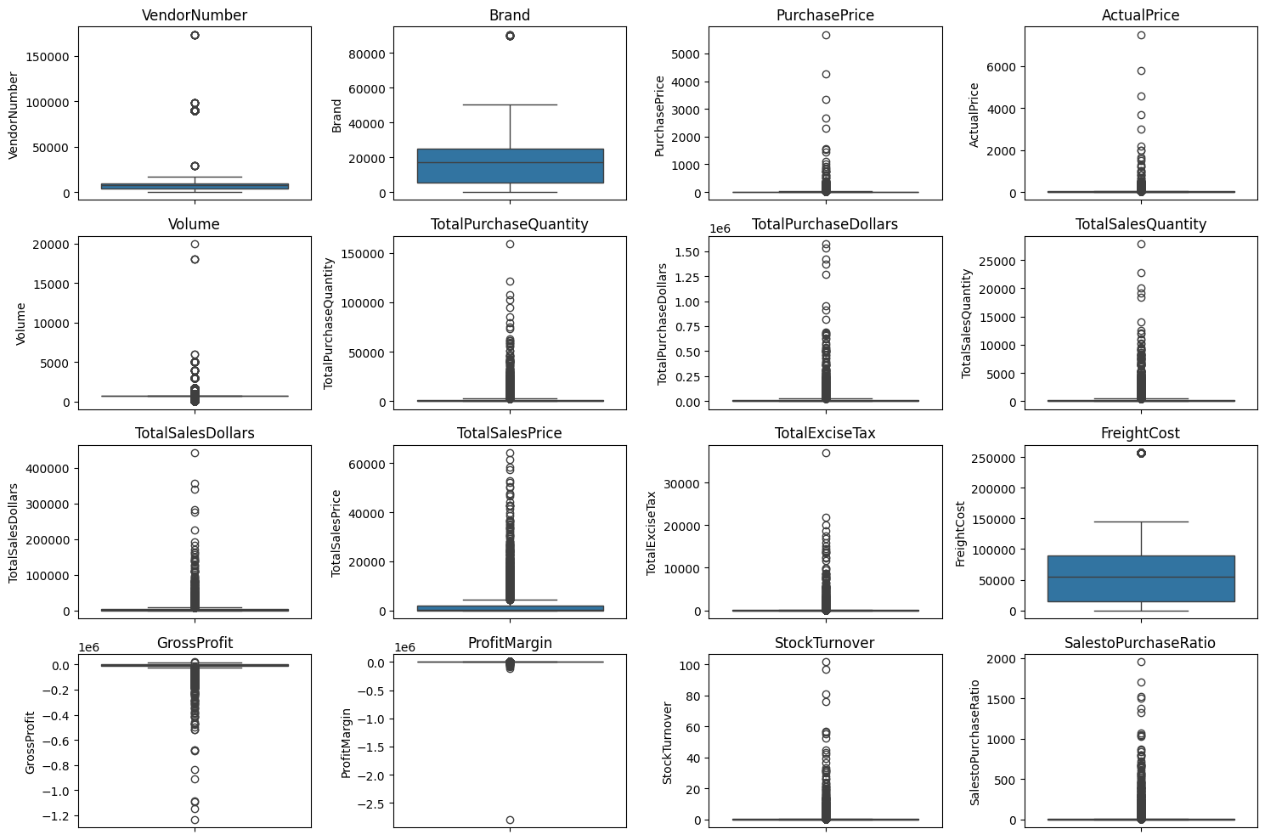

**Summary Statistics Insights:**

* **Negative & Zero Values:**
  + *Gross Profit* drops to **-1.25M**, indicating losses from high costs or heavy discounting.
  + *Profit Margin* reaches **-∞**, suggesting revenue is zero or below cost.
  + *Sales Quantity & Sales Dollars* show **0 values**, highlighting unsold or obsolete stock.
* **High Outliers:**
  + ***Purchase & Actual Prices:*** Max values (**5,681 & 7,499**) far exceed means (~24 & ~35), pointing to premium-priced items.
  + ***Freight Cost:*** Wide range (**0.09 to 257K**) suggests bulk shipments or logistics inefficiencies.
  + ***Stock Turnover:*** From **0 to ~100**, showing fast-selling vs stagnant items; values >1 indicate rapid sales.
  + ***Sales-to-Purchase Ratio:*** Peaks near **1,900**, showing excess sales over purchases due to backlog or clearance.
* **Distribution Patterns:**
  + Most metrics are **right-skewed**, driven by a few high-value outliers.
  + Quantities and volumes cluster near zero, indicating low sales frequency or slow-moving inventory.

**Data Filtering**

To enhance the reliability of the insights, we removed inconsistent data points where:

* Gross Profit ≤ 0 (to exclude transactions leading to losses).
* Profit Margin ≤ 0 (to ensure analysis focuses on profitable transactions).
* Total Sales Quantity = 0 (to eliminate inventory that was never sold).

**Count Plot by Vendor Name & Description (Brand)**

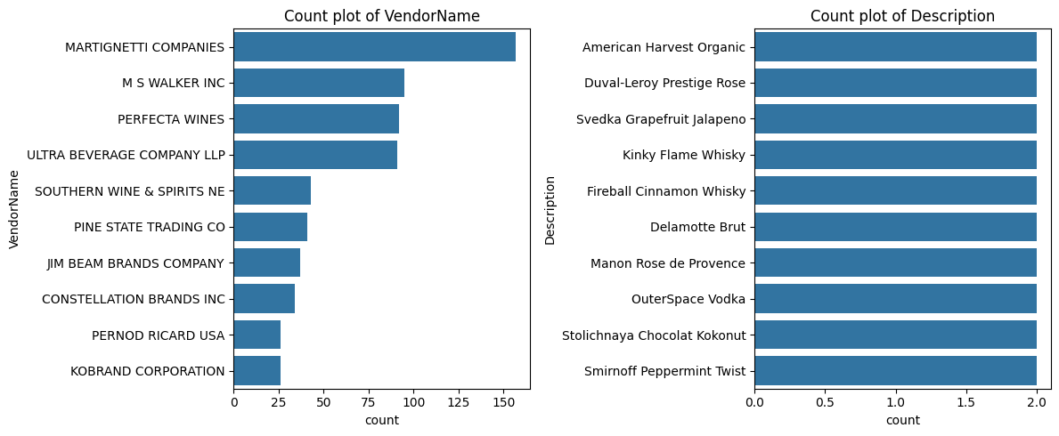

The graph shows two main findings:

* **Vendor dominance:** A few vendors, especially "MARTIGNETTI COMPANIES," handle most transactions, while others trail far behind.
* **Product variety:** Each top-selling product appears only twice, indicating sales are spread thinly across many items rather than concentrated in a few.

This means the business relies heavily on select vendors but offers a wide, low-volume product selection.

**Correlation Insights**

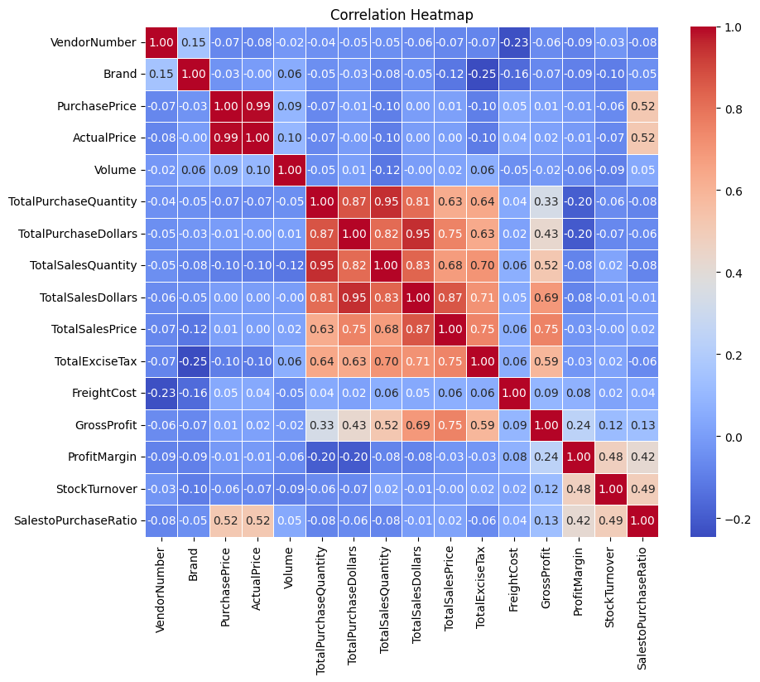

**Insight:**

* **Purchase Price vs. Total Sales Dollars & Gross Profit:**  
  Weak correlation (−0.012 and −0.016), indicating that price variations do not significantly impact sales revenue or profit.
* **Total Purchase Quantity vs. Total Sales Quantity:**  
  Strong correlation (0.999), confirming efficient inventory turnover.
* **Profit Margin vs. Total Sales Price:**  
  Negative correlation (−0.179), suggesting increasing sales prices may lead to reduced margins, possibly due to competitive pricing pressures.
* **Stock Turnover vs. Gross Profit & Profit Margin:**  
  Weak negative correlation (−0.038 & −0.055), indicating that faster stock turnover does not necessarily equate to higher profitability

**Research Questions & Key Findings**

1. **Brands for promotional or Pricing Adjustments**

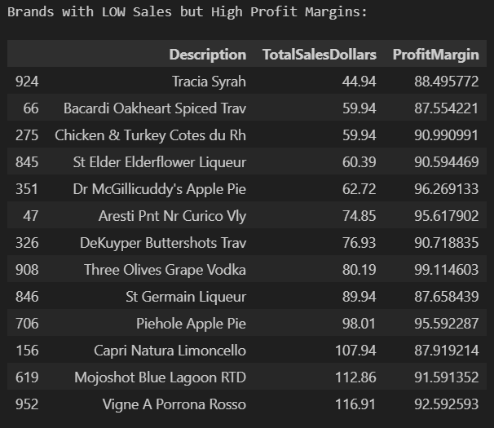

A total of **13 Brands** exhibits lower sales but High Profit Margins, which could benefit from Target Marketing, promotions, or price optimizing to increase volume without compromising profitability.

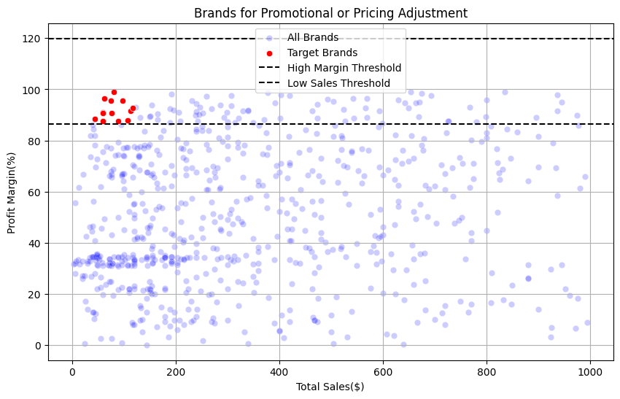

1. **Top Vendors & Brands by Sales:**

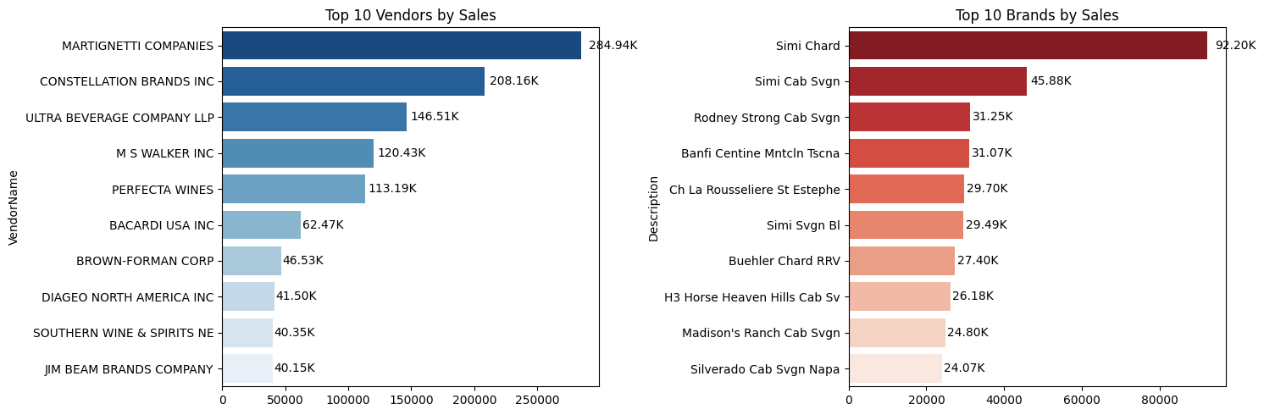

* **Vendor sales are highly concentrated**: Top vendors dominate—MARTIGNETTI COMPANIES accounts for nearly 285K sales, far ahead of others, revealing dependency on a few suppliers.
* **Brand sales are less concentrated**: Even the top brand (Simi Chard) only reaches 92.20K in sales, with a steep drop after, suggesting customers are spread across many brands rather than few highly popular names.
* **Potential action**: Reliance on a small set of vendors could be a risk or opportunity for negotiation; meanwhile, expanding or focusing the brand mix may offer growth, as brand preferences are more fragmented.

1. **Top Vendors by Sales & Purchase Contribution**

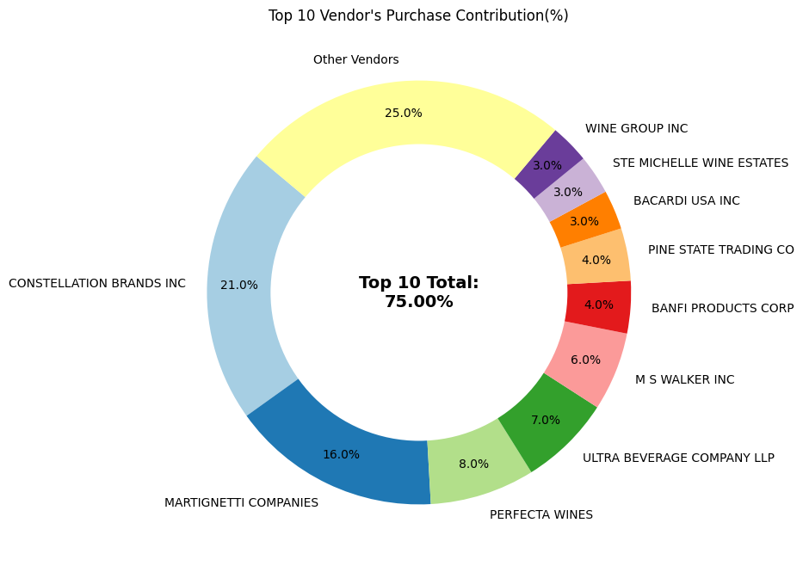

The **Top 10 Vendors** contributes **75.00% of total purchases**, while the **remaining vendors** contribute only **25.00%**. The over-reliance on a few vendors may introduce risks such as supply chain disruptions, indicating a need for diversification.

1. **Impact** **of Bulk Purchasing on Cost Savings**

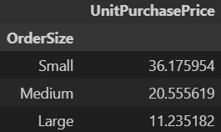

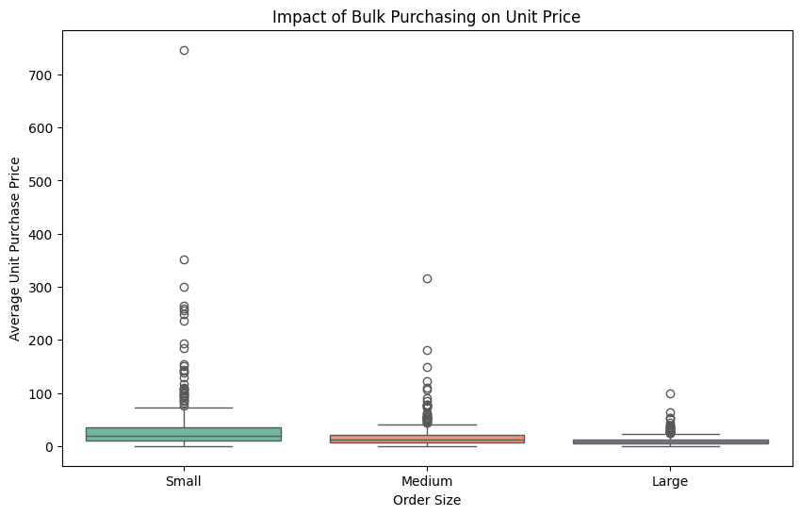

* Vendors placing **Large Orders** achieve the **lowest unit price**, enabling higher margins if inventory is managed well.
* There is a **significant price gap** (~70% reduction) between Small and Large orders, showing strong cost benefits of bulk purchases.
* This confirms that **bulk pricing strategies** effectively incentivize larger purchases, boosting overall sales despite reduced per-unit prices.

1. **Identifying Vendors with Low Inventory Turnover**

**Total Unsold Inventory Capital:** $15.84M

Slow-moving inventory increases storage costs, reduces cash flow efficiency, and affects overall profitability.

Identifying vendors with low inventory turnover enables better stock management, minimizing financial strain

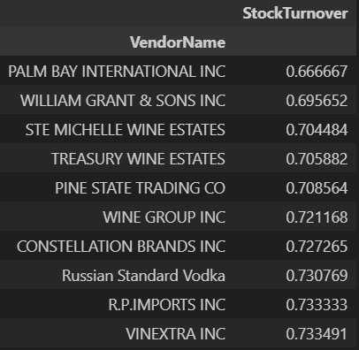

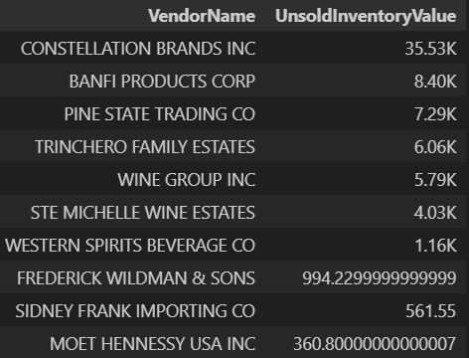

1. **Profit Margin Comparison: High vs Low- Performing Vendors**

Top Vendors 95% CI: (55.51, 62.72), Mean: 59.12

Low Vendors 95% CI: (43.85, 50.03), Mean: 46.94

* Low-Performing Vendors maintain higher margins but struggles with sales volume, indicating potential pricing inefficacies or market reach issue.
* Actionable Insights:
* Top- Performing Vendors: Optimize profitability by adjusting pricing, reducing operational costs, or offering bundled promotion.
* Low-Performing Vendors: Improve marketing efforts, optimize prizing strategies, and enhance distribution networks.

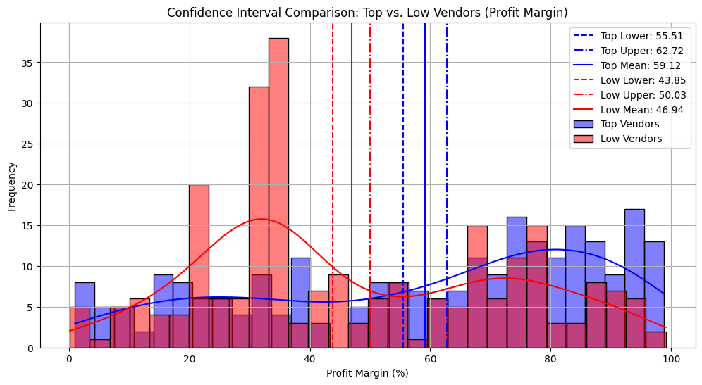

1. **Statistical Validation of Profit Margin Differences:**

**Hypothesis Testing:**

**H₀ (Null Hypothesis):** No significant difference in profit margins between top and low-performing vendors.

**H₁ (Alternative Hypothesis):** A significant difference exists in profit margins between the two vendor groups.

**Result:** The null hypothesis is rejected, confirming that the two groups operate under distinctly different profitability models.

**Implication:** High-margin vendors may benefit from better pricing strategies, while top-selling vendors could focus on cost efficiency.

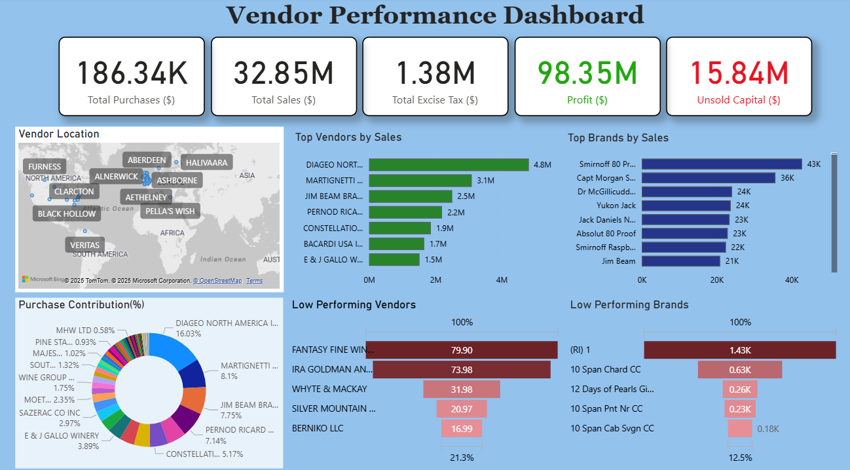**POWER-BI Dashboard**

**Final Recommendations:**

* Re-evaluate pricing for low-sales, high-margin brands to boost sales without sacrificing profitability.
* Diversify vendor- partnership to reduce dependency on a few suppliers and mitigate supply chain risks.
* Leverage bulk purchasing advantages to maintain competitive pricing optimizing inventory management.
* Optimize slow- moving inventory by adjusting purchase quantities, launching clearance sales, revising storage strategies.
* Enhance marketing and distributing strategies for low- performing vendors to drive higher sales volume without compromising profit margins.
* By implementing these steps, the company can:
* **Achieve Higher sustainable profitability.**
* **Mitigate the potential risks.**
* **Enhance overall operational inefficiencies.**